This was happening:
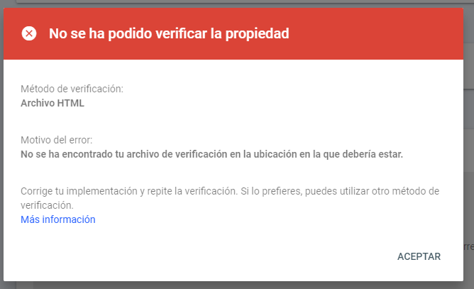
That was because:
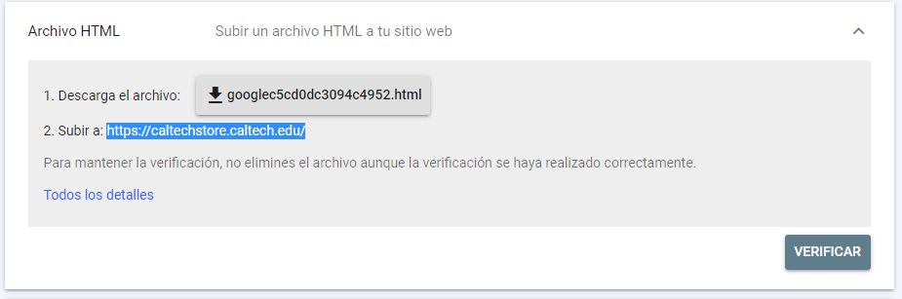
And on netsuite backend, this domain caltechstore.caltech.edu is not created, because is the final domain:
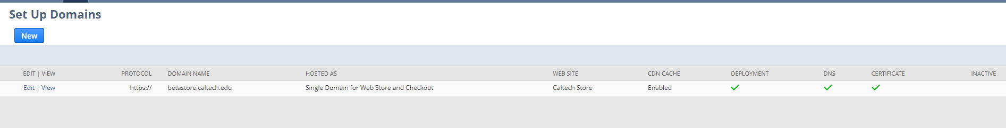
Because of that throws that error.
So this step should be done on post go live.

